E15 Sales Set a New Record in 2024, and There’s Reason
for Optimism about the Future

April 4, 2025

By Scott Richman, Chief Economist

U.S. sales of E15, a blend of 15% ethanol and 85% gasoline, reached a record 1.24 billion gallons in 2024, an increase of 11% over 2023, according to a Renewable Fuels Association analysis of data released by state agencies in Minnesota and Iowa (Exhibit 1). The increase was primarily due to continued growth in the number of retail stations offering E15 in the U.S. and both states. Notably, the number of stations offering E15 in Iowa jumped by more than 50% to 763, accounting for more than a third of retail locations selling gasoline in the state.

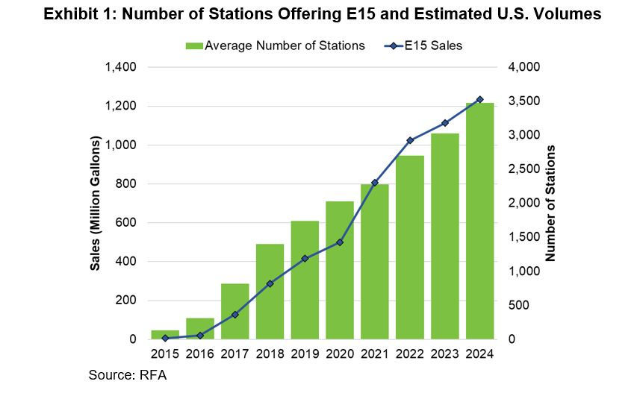

Moreover, E15 offers significant savings to consumers. In Minnesota, E15 prices were $0.18/gallon less expensive than regular unleaded gasoline (E10) at the pump, on average.

E15 sales by stations that reported volumes to the state agencies increased 12% in Minnesota and 44% in Iowa (Exhibit 2). However, not all stations that sell E15 report their volumes. Accordingly, the RFA used supplemental information from the Minnesota Dept. of Commerce and the Iowa Dept. of Revenue to estimate total statewide sales (i.e., including those by stations that sold E15 but did not report their volumes).

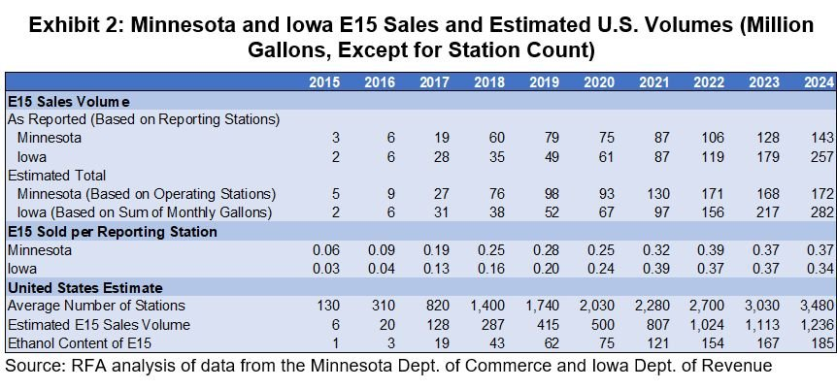

There are no official statistics on U.S. E15 volumes, but national sales can be estimated using Minnesota and Iowa data, given that the two states account for more than a third of all U.S. stations offering E15. RFA estimates national sales by multiplying its count of U.S. E15 stations by the average estimated volume per station in the two states. On average over the course of 2024, nearly 3,500 stations offered E15 in the U.S., compared to just over 3,000 in 2022.

A key reason why the average E15 volume per station has increased over the last six years is that sales have been allowed during the summer months in conventional gasoline areas. In 2019 the Trump administration issued a rule allowing E15 to be sold year-round, eliminating an arcane and outdated regulatory requirement that had previously restricted retailers from offering E15 in the summertime.[1] However, in 2021 the D.C. Circuit Court of Appeals vacated that rule, deciding in favor of oil refiners who argued the Environmental Protection Agency had exceeded its authority. The decision did not affect E15 sales that summer, and for the last three summers the EPA has granted waivers for E15 from the regulatory requirement, citing “extreme and unusual fuel or fuel additive supply circumstances,” such as those that existed after Russia invaded Ukraine.

If the administration does not take action within the next month, E15 sales will drop sharply in most of the country this summer, as occurred seasonally in conventional gasoline areas prior to 2019. However, in a January executive order declaring a national energy emergency, President Trump stated that the EPA administrator, “shall consider issuing emergency fuel waivers to allow the year-round sale of E15 gasoline to meet any projected temporary shortfalls in the supply of gasoline across the Nation.” The ethanol industry is hopeful that waivers will be provided and E15 sales will be allowed to continue unfettered this summer.

Yet, the main reason for optimism about E15 is initiatives in the U.S. Congress and in California. Instead of ad hoc waivers allowing E15 sales each summer, the best solution for both fuel supply chain participants and consumers would be passage of the Nationwide Consumer and Fuel Retailer Choice Act (S. 593). The key provisions of the bill were included in the initial draft of the December continuing resolution to fund government operations, and while a streamlined version of the resolution without the provisions was eventually passed, the process demonstrated that a critical mass of support exists in Congress. Passage would leverage expanding E15 infrastructure facilitated by $537 million in funding through the Higher Blends Infrastructure Incentive Program (HBIIP).

In California, the only state where E15 is not yet allowed to be sold, Governor Newsom sent a letter in October directing the state’s Air Resources Board (CARB) to expedite approval of the blend. Last week, CARB publicly posted the “Tier II” report on E15, completing the second phase of a three-tiered “Multimedia Evaluation” of the fuel. A working group will now complete a Tier III Multimedia Risk Assessment and conduct a scientific peer review. The California Legislature is currently considering providing funding requested by the governor to complete the regulatory process to authorize the use of E15 and conduct program implementation. It is expected that E15 would be readily adopted in California, given high gasoline prices in the state, the rapid uptake of E85 under the Low Carbon Fuel Standard, and the compatibility of retail infrastructure.

While we are not “counting our chickens before they hatch,” there is more reason than ever to be optimistic about the future of E15.

[1] EPA limits the volatility of gasoline during the “high ozone season” every summer (June 1-September 15). Prior to the 2019 rule, the practical limit on the Reid vapor pressure (RVP) of E10 sold in conventional gasoline areas was 10 pounds per square inch (psi), but E15 was held to a 9-psi limit. EPA’s 2019 rule effectively extended the E15 volatility limit to 10 psi, creating parity for E15 and E10.

